External Newsletter Analysis

Purpose of the Analysis
The goal of this analysis is to understand how the external newsletter (Judi Health Insights) is currently performing and identify opportunities to improve engagement, readership, click behavior, list growth, and conversions. The analysis uses HubSpot newsletter data from June 2024 through June 2026 and focuses on open rate, click rate, click-through rate, read/skim/glance behavior, deliverability, bounce rate, top-clicked links, and newsletter format trends.
Metrics Analyzed
Metric | Formula | Description
Time Sent Out |  | Time at which email was sent
Delivery Rate | (# of Emails Delivered / # of Emails Sent) * 100 | % of successfully delivered emails out of those that were sent
Open Rate | (# of Unique Opens / # of Emails Delivered) * 100 | % of people who opened your email out of the people who were delivered your email
Click Rate | (# of Clicks / # of Delivered Messages) * 100 | % of people who clicked a link in your email out of the people who were delivered your email
Click Through Rate | (# of Clicks / # of Opens) * 100 | % of recipients who clicked a link in your email out of those who opened it
Read vs. Skimmed vs. Glanced |  | Read - Contacts opened and viewed it for eight or more seconds.  Skimmed - Contacts opened and viewed it for two to eight seconds.  Glanced - Contacts opened and viewed it for zero to two seconds.
Conversion Rate | (# of Conversions / # of Emails Delivered) * 100 | % of conversions (i.e., purchases, downloads, etc.) out of the emails delivered
List Growth |  | Changes in our email list size month over month

Performance Snapshot

Overall Performance
The newsletter is reaching a large external audience, with an average of roughly 46.6K delivered emails per send and consistently strong deliverability. The average delivery rate is approximately 98.7%, which suggests that inbox delivery is generally not an issue. The bigger opportunity is to improve the number of recipients who engage with the delivered email and how they are engaging.
Average engagement across the dataset is modest: open rate is around 4.7%, click rate is around 0.6%, and click-through rate is around 13.1%. This suggests that the newsletter is being delivered successfully, but only a small portion of recipients are opening and clicking on one of the links.

Consumption: Read vs. Skimmed vs. Glanced
Reader consumption is mixed. On average, about 33.1% of openers read the newsletter (view for longer than 8 seconds), 31.7% skimmed it (view for 2 to 8 seconds), and 35.2% glanced at it (view for 0 to 2 seconds).
The strongest read-depth example is the January 2026 send, which had 44.1% read and 23.1% glanced. That send included a webinar registration link as the top-clicked link, suggesting that direct, high-value webinar CTAs may support stronger engagement.
Recent newsletters show weaker consumption, with 46.1% and 46.5% of readers only glancing at the May and April 2026 newsletters, respectively. While these emails included webinar registration opportunities, the primary CTA was positioned lower in the email and surrounded by numerous links to external articles and videos. This may have created a more overwhelming experience for readers and diluted attention away from the desired action. Higher-performing newsletters generally feature a clear webinar or replay CTA near the top and a more focused content mix.

Strong vs. Weak Months

Strong Months
November 2025: This was the strongest click-performance month in the dataset, with 897 clicks, a 1.9% click rate, and a 33.7% click-through rate. The top-clicked link was a Judi Health replay about unifying medical and pharmacy benefits.
December 2025: This was also a top performer, with 602 clicks, a 1.3% click rate, and a 22.3% click-through rate. The top-clicked link was again the Judi Health replay about unifying medical and pharmacy benefits.
April 2025: This send performed well across both opens and clicks, with a 5.7% open rate, 428 clicks, 0.96% click rate, and 16.9% click-through rate.
January 2026: This was the strongest read depth send, with 44.1% read, 32.8% skimmed, and only 23.1% glanced.

Weak Months
September 2024: This had the lowest click rate in the dataset, with a 0.3% click rate and 6.8% click-through rate, suggesting weaker CTA or content pull.
November 2024: This had the lowest open rate in the dataset at 2.97%, along with a 0.3% click rate. No mention of a webinar in this email.
July 2025: This had a decent open rate of 4.8%, but only a 0.3% click rate and 7.3% click-through rate, suggesting recipients opened the email but were not strongly motivated to click.
June 2024: This was the main deliverability outlier, with a 92.8% delivery rate, 6.9% bounce rate, 1,380 hard bounces, and 1,893 soft bounces.

Key Findings

Finding 1: Readers engage most with webinar and replay content.
The strongest-performing links and months are tied to webinar registrations and webinar replays. The top-clicked links in the strongest click months include Judi Health replay content, Zoom webinar registration links, ON24 event links, Benefit News webinars, and Achieve Engagement webcasts.
Implication: The newsletter should prioritize high-value, action-oriented content such as webinars, replays, research, and educational resources instead of relying too heavily on general article links.

Finding 2: Top-clicked content is usually tied to a clear CTA.
The strongest click months had clear destinations for readers, such as webinar replay pages or registration links. November 2025 and December 2025 both performed strongly when the top-clicked link was the Judi Health replay about unifying medical and pharmacy benefits.
Implication: Each newsletter should have one primary CTA near the top, supported by a few secondary links lower in the email.

Finding 3: Engagement is inconsistent by month.
Some months show strong click behavior even when open rates are lower. For example, October 2025 had a lower open rate of 2.96%, but a very high 33.3% click-through rate, meaning the people who opened were highly engaged.
Implication: Open rate and click-through rate should be evaluated separately. Low opens may point to subject line, timing, or audience issues, while high CTR may indicate that the actual content was valuable to the people who opened.

Finding 4: The current format has opportunities for improvement.
The email names are repetitive and long, using similar naming conventions across months. The data also shows that many readers are glancing instead of reading, especially in recent sends.
Implication: The newsletter may benefit from shorter subject lines, clearer naming conventions, fewer sections, better hierarchy, and stronger CTA placement.

Observations
- The newsletter reaches a large audience, with delivered volume usually around 44K–48K+ per send.
- Delivery rate is generally strong, averaging around 98.7%, with June 2024 as the major bounce-rate outlier.
- Open rates are usually around 4–6%, with the strongest open rates around 5.7–5.8% and weakest around 3%.
- Click performance varies more than opens, with the highest click rate at 1.9% and weaker months closer to 0.3–0.4%.
- Click-through rate (CTR) varied significantly across sends, ranging from approximately 7% to 34%. The highest CTRs occurred in newsletters featuring webinar registrations, webinar replays, or event-related content, while newsletters focused on standard articles or company news generally produced lower CTRs.
- Strongest top-clicked links are often webinars, replays, or event-related resources.
- Recent sends show more glancing behavior, especially April and May 2026, where glance rates were above 46%.
- All emails were sent during weekdays, but the time they were sent differed. The most common windows were early afternoon and late afternoon.
  - Late afternoon (3–4:59 PM) sends had the strongest click performance. These had the highest average open rate, click rate, and CTR. This group includes some of the strongest click performers, like the November 2025 and December 2025 newsletters. However, this same bucket also had a higher average glance rate, so late afternoon may be good for quick action/clicks, but not necessarily deep reading.
  - Evening sends had the strongest read depth. The evening group had the highest average read rate and lowest glance rate. The January 2026 newsletter, sent at 7:42 PM, had the highest read rate in the dataset at 44.1% read and only 23.1% glanced.

Conversion Tracking Plan
Use a two-step conversion tracking process:
- Newsletter click tracking: Use HubSpot and UTMs to track who clicks newsletter CTAs, especially webinar registration and replay links.
- Webinar/event follow-up tracking: Cross-reference newsletter clickers with Zoom or webinar attendee lists to identify who registered, attended, watched a replay, or engaged after the event.
This would allow the team to move beyond “who clicked?” and answer better questions like:
- Which newsletter links drove registrations?
- Which registrants actually attended?
- Which attendees are already in our sales pipeline?
- Which accounts repeatedly engage with newsletter content?
- Which content types influence pipeline movement?

List Growth
Month | List Size | List Growth
January | 66163
February | 66856 | +693
March | 67359 | +503
April | 67939 | +580
May | 68293 | +354
June | 68905 | +612
July | 77605 | +8,700
From January through June, growth averaged roughly +548 subscribers/month. However, during July (our rebrand month), we gained 8,700 subscribers - about 16x normal monthly growth. Other observations include:
- Growth is generally positive and consistent. The list increased from 65,924 on Jan 1 to 77,605 on Jul 31, a net gain of 11,681 subscribers (+17.7%) over seven months.
- Most growth occurs in sudden jumps, not daily accumulation. Several large step changes stand out, for example a +293 increase from April 19 to April 20 and a +8451 increase from July 12 to July 13. This suggests list growth is being driven by specific campaigns, partnerships, or events/webinars rather than only website signups
- Weekend growth is noticeably slower – most weekends add 0-2 subscribers.
- There are occasional subscriber declines, i.e. a 105 decline from April 2 to 3.
Despite the current list size being over 70,000, the delivered audience is generally around 46K–48K.
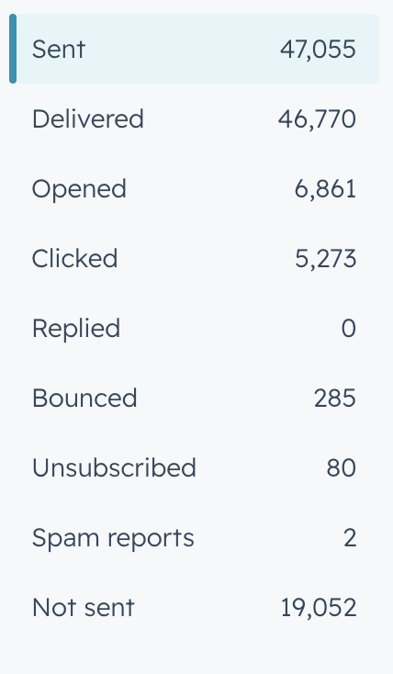
Above is a snapshot of the recipient analytics for our most recent July newsletter. An important callout is that the email was not sent to 19,052 receipts. The most common reason for this were that the recipient was “previously hard bounced.” We can improve deliverability by addressing inactive and undeliverable contacts. Conducting regular list hygiene reviews, removing invalid email addresses, and implementing re-engagement campaigns for inactive subscribers can help improve list quality, provide a more accurate view of the reachable audience, and strengthen overall email performance.

Recommended Improved Newsletter Format

Suggested Format
Header / Subject Line
- Shorter, clearer, and varied by month.
- Use topic-driven naming instead of generic “External Newsletter.”
Top Section
- One strong headline.
- One short summary explaining why the reader should care.
- One primary CTA button placed near the top.
Main Content
- Feature one high-value asset: webinar replay, upcoming webinar, research, market insight, or timely thought leadership.
- Use 2–3 supporting links maximum.
Secondary Section
- Related news, blog content, or resource links.
- Keep links grouped by theme rather than spread throughout the email.
Footer / Engagement Section
- Include “We’re hiring,” company updates, or social links only if they are secondary and do not compete with the main CTA.

Recommendations
- Shorten and vary subject lines / email names.
The recurring names are long and repetitive, which makes it harder to quickly understand what each newsletter is about.
- Prioritize webinar, replay, and high-value educational content.
These appear most often among the strongest-performing links and months.
- Place the main CTA higher in the email.
The strongest engagement appears tied to clear CTA destinations like webinar registrations and replays.
- Reduce content density.
Since many readers skim or glance, the format should be shorter, more visual, and easier to scan.
- Improve conversion tracking.
Add UTMs, campaign tags, and HubSpot reporting to connect newsletter clicks to registrations, attendance, demo requests, and content downloads.
- Cross-reference newsletter engagement with webinar attendance.
Use HubSpot click data plus Zoom attendee data to understand which newsletter readers actually convert into event attendees or sales-relevant contacts.
- Track list growth and source quality.
Add list source, new subscribers, unsubscribes, and net list growth to future reporting.
- Monitor bounce rate and list hygiene.
Bounce rates are mostly manageable, but June 2024 shows that list quality can affect deliverability.
- Test new content formats.
Try shorter copy, stronger visual hierarchy, GIFs or video thumbnails, clearer buttons, more personalized intros, employee/company highlights, and fewer competing links.

Charts
Average CTR by Top Clicked Link Content Type
Webinar Replay █████████████████ 17.49%
Webinar Registration ████████████ 11.80%
Company News ███████████ 11.25%
Event Content ██████████ 10.66%
Educational Article █████████ 9.62%

Newsletters whose top-clicked link was webinar-related content tended to generate the strongest overall click-through rates. Emails where the most-engaged link was a Webinar Replay averaged a CTR of 17.5%, while newsletters with Webinar Registration links averaged 11.8%, outperforming newsletters with all other content types. These categories, being the highest-performing content types, suggest that the audience is actively seeking educational experiences and opportunities to learn from subject matter experts.

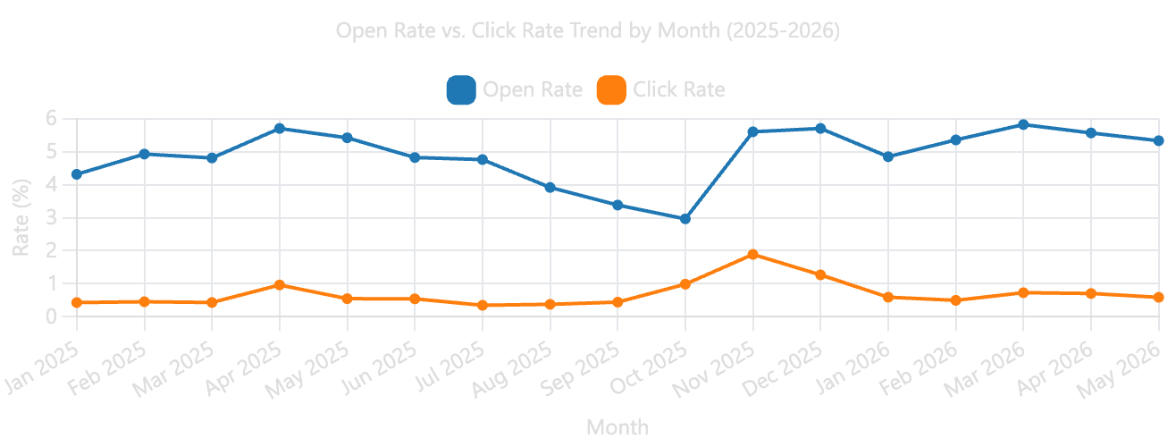A higher open rate does not correlate to a higher click rate – making people want to click into the emails and click throughout the emails are two different problems to solve.

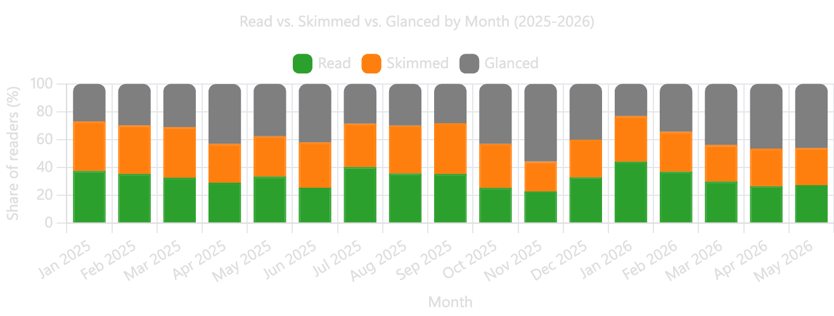Most of our audience is simply glancing at or skimming our emails. Ideally, we would want most people to be reading our emails, so we need to figure out ways to make our content more engaging and digestible (i.e. more images, less external links, more targeted content, etc.).

